Capstone Assignment DSA
Test Cases
Test Case 1: Successful registration
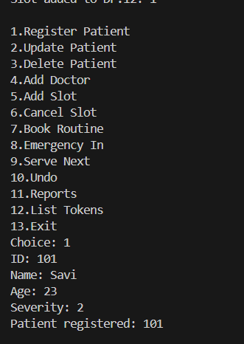
Test Case 2: Update existing patient
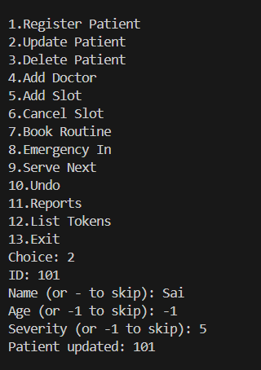
Test Case 3: Add Doctor
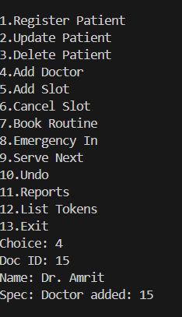
Test Case 4: Duplicate Doctor
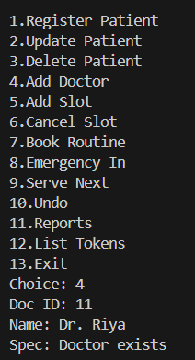
Test Case 5: Add Slot to Schedule
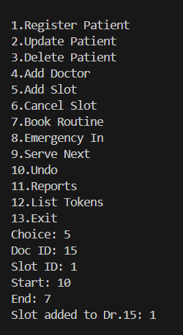
Test Case 6: Doctor doesn't exist
